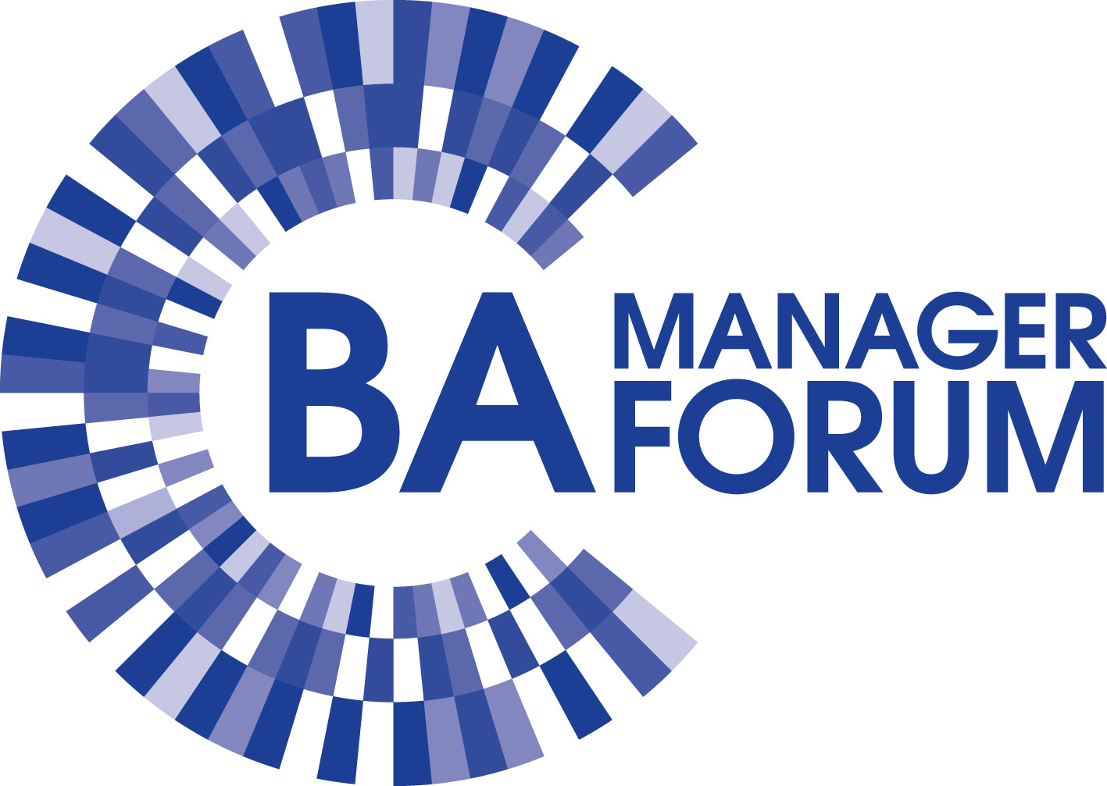  Porter’s Five Forces Framework  Chapter 1 Page 6 |  | MOST Analysis  Chapter 1 Page 9
Resource Audit  Chapter 1 Page 10 |  | Boston Box  Chapter 1 Page 12
SWOT Analysis  Chapter 1 Page 14 |  | Ansoff’s Matrix  Chapter 1 Page 16
McKinsey’s 7'S  Chapter 1 Page 17 |  | Leavitt's Diamond  Chapter 1 Page 20

Capability Modelling  Chapter 1 Page 23 |  | Value Streams  Chapter 1 Page 26
POPIT Model  Chapter 1 Page 29 |  | Critical Success Factors  Chapter 1 Page 30
Key Performance Indicators  Chapter 1 Page 30 |  | Balanced Business Scorecard  Chapter 1 Page 31
Interviewing  Chapter 2 Page 35 |  | Repertory Grid  Chapter 2 Page 39

Workshops  Chapter 2 Page 41 |  | Observation  Chapter 2 Page 50
Shadowing  Chapter 2 Page 53 |  | Protocol Analysis  Chapter 2 Page 55
Ethnographic Studies  Chapter 2 Page 56 |  | Surveys  Chapter 2 Page 59
Sampling  Chapter 2 Page 62 |  | Special-Purpose Records  Chapter 2 Page 66

Document Analysis  Chapter 2 Page 67 |  | Rich Pictures  Chapter 2 Page 70
Mind Maps  Chapter 2 Page 72 |  | Fishbone Diagrams  Chapter 2 Page 74
Context Diagram  Chapter 2 Page 75 |  | Stakeholder Nomination  Chapter 3 Page 81
Background Research  Chapter 3 Page 81 |  | Stakeholder Wheel  Chapter 3 Page 82

Power/Interest Grid  Chapter 3 Page 84 |  | Social Network Analysis  Chapter 3 Page 89
Personas  Chapter 3 Page 92 |  | Cynefin  Chapter 3 Page 95
CATWOE  Chapter 3 Page 98 |  | Business Activity Modelling  Chapter 3 Page 101
RASCI Charts  Chapter 3 Page 105 |  | Stakeholder Management Planning  Chapter 3 Page 108

Thomas–Kilmann Conflict Mode Instrument  Chapter 3 Page 111 |  | Principled Negotiation  Chapter 3 Page 113
Value Proposition Analysis  Chapter 4 Page 120 |  | Value Chain Analysis  Chapter 4 Page 122
Organisation Diagram  Chapter 4 Page 125 |  | Business Event Analysis  Chapter 4 Page 128
Activity Diagrams  Chapter 4 Page 132 |  | Business Process Modelling  Chapter 4 Page 135

Task Analysis  Chapter 4 Page 139 |  | Business Rules Analysis  Chapter 4 Page 144
Decision Tables  Chapter 4 Page 146 |  | Decision Trees  Chapter 4 Page 146
Gap Analysis  Chapter 4 Page 152 |  | Process Redesign Patterns  Chapter 4 Page 155
Options Identification  Chapter 5 Page 160 |  | Feasibility Analysis  Chapter 5 Page 164

Force-Field Analysis  Chapter 5 Page 167 |  | Cost–Benefit Analysis (CBA)  Chapter 5 Page 169
Benefits Categorisation  Chapter 5 Page 176 |  | Impact Analysis  Chapter 5 Page 178
Risk Analysis  Chapter 5 Page 180 |  | Investment Appraisal  Chapter 5 Page 183
Business Case Report Creation  Chapter 5 Page 188 |  | Business Case Presentation  Chapter 5 Page 191

4 A's Communication Model  Chapter 5 Page 192 |  | User Analysis  Chapter 6 Page 200
Scenarios  Chapter 6 Page 203 |  | User Stories  Chapter 6 Page 208
Planning Poker  Chapter 6 Page 211 |  | Storyboarding  Chapter 6 Page 215
Prototyping  Chapter 6 Page 217 |  | Wireframes  Chapter 6 Page 221

Hothousing  Chapter 6 Page 223 |  | Timeboxing  Chapter 6 Page 226
MoSCoW Prioritisation  Chapter 6 Page 229 |  | Requirements Organisation  Chapter 6 Page 232
Product Backlog  Chapter 6 Page 236 |  | Requirements Documentation  Chapter 6 Page 238
Acceptance Criteria Definition  Chapter 6 Page 243 |  | Requirements Validation  Chapter 6 Page 245

Requirements Management  Chapter 6 Page 251 |  | Requirements Traceability Matrix  Chapter 6 Page 256
Business Use Case Modelling  Chapter 6 Page 258 |  | Use Case Diagrams  Chapter 6 Page 262
Use Case Descriptions  Chapter 6 Page 262 |  | Entity Relationship Modelling  Chapter 6 Page 267
Class Modelling  Chapter 6 Page 275 |  | CRUD Matrix  Chapter 6 Page 281

State Machine Diagrams (SMDS)  Chapter 6 Page 283 |  | Cultural Analysis  Chapter 7 Page 288
Kurt Lewin’s Model of Organisational Change  Chapter 7 Page 293 |  | SARAH Model  Chapter 7 Page 295
Kotter's Approach to Change  Chapter 7 Page 297 |  | Outcome Frame  Chapter 7 Page 301
Learning Cycle  Chapter 7 Page 303 |  | Conscious Competence Model  Chapter 7 Page 306

Benefits Management  Chapter 7 Page 308 |  | Benefits Realisation  Chapter 7 Page 312

